Power generation: engineering challenges of a low carbon future
A Morris
Technical Head Integrity
E.ON ENGINEERING UK
andy.p.morris@eon-engineering-uk.com

Summary
Climate change issues have combined with the other aspects of Government Energy Policy across the world to create some significant challenges for the Power industry. For example, in the UK these challenges include, achieving a 60% reduction in CO₂ by 2050, whilst ensuring security of energy supplies, which are affordable, all within a competitive market framework. This means that the Power Industry has to work hard to find new ways of delivering energy to a wide range of Industrial and Retail customers. In addition, there are significant challenges associated with developing new technologies that are delivered on time and are technically effective, thereby mitigating the risk associated due to the retirement of current plant and the need to reduce emissions. These challenges have prompted an upsurge in R&D activities and this paper will touch on some of the more tangible projects and issues.
It’s beneficial to set the scene and the UK experience provides a good platform to explore. Following the privatisation of the electricity industry in the UK there was a focus on operating existing generating plant as effectively as possible within a new and developing market framework. The survivors in this market have emerged as vertically integrated energy companies, supplying not only electricity but also gas and other services to a mass market. The issue of climate change has brought energy centre-stage, but also important is security of supply due to diminishing North Sea oil and gas, rising energy costs and the issue of fuel poverty.
During the last 100 years electricity supply has been dominated by a centralised generation model, using fossil, some hydro and, in the latter half of the century, nuclear. During the 1990’s saw an increasing influx of new gas-fired CCGT technology, and this can now be viewed as the start of an acceleration in technology development.
The range of technologies, including fuel cells that are now becoming available will radically alter the centralised generation model. Understanding these technologies, their strengths and weaknesses will enable the industry to be better able to identify opportunities that will arise in a changing market.
Within this rapidly changing landscape there is also a need to maintain an aging fleet of generating stations to ensure a seamless transition to new and improved energy technologies. This paper describes the evolution of the plant mix within the UK. Some examples are provided of challenging engineering problems that have arisen during this period, which illustrate the difficulty associated with correlating simulation models against test or service data. Future R&D issues are also described, with a particular focus on aspects of clean coal technology, which offers significant benefits in terms of increased efficiency and subsequent reductions in CO₂ emissions from conventional fossil fired plant.
The evolution of the de-regulated UK market has led to many challenges. These are now compounded by the necessity to address climate change in a vigorous and sustainable manner. Crucial to a successful outcome is the development of a new generation of engineers and scientists, of all disciplines and able to operate in a rapidly changing world wide market. The CCOPPS (www.ccopps.eu) project provides valuable support to this and should be applauded.
- UK Generation Overview
During the 1960’s and 70’s there was a large demand for electricity, which was met by the construction of many stations, predominantly with Units of 500MW and greater capacity. This construction phase was undertaken by the Central Electricity Generating Board (C.E.G.B), who was responsible for production in England and Wales. During this period there was a readily available supply of UK coal and low Oil prices. During the late 1980’s the industry was privatised and this led to the formation of the successor Power Companies, one of whom was Powergen, later to be taken over by E.ON in the early 2000’s.
The 1990’s saw a period of considerable change in the UK Power industry. Environmental issues came increasingly to the fore, fuel prices for coal reduced and there was a dash for Gas that led to the construction of several Gas fired power stations. In essence the generation capacity became fragmented, with a few major players and many independent power producers. During this period there was considerable pressure on Power companies to maximise the return on their assets. This limited the amount of reinvestment in capital plant requiring plant owners to strive for more innovative ways of operating and maintaining the plant to ensure availability, whilst managing the risk of plant failures.
Climate change issues have increasingly become headline news in the UK and around the world. Power companies and other energy users clearly recognise their responsibility and actively strive to reduce emissions through ongoing operational improvements and R&D. In tandem with this the European Large Coal Plant Directive (LCPD) requires that stations that can’t meet specific emissions targets will close by 2015. A number of stations have subsequently opted out of the LCPD and will close in 2015; many of those that are opted in must install appropriate measures to reduce emissions. In addition many of the opted in plant must consider the phased renewal of sections of high and low temperature pipework and components that are coming close to life expiry. Hence, considerable operational challenges will persist for all current plant in the short and medium term. In addition the options for future nuclear energy are still being debated as part of the consultation process following the publication of the UK Energy White Paper on 23rd May 2007.
- Examples of Recent Engineering Challenges
Many of the engineering challenges associated with maintaining plant availability in recent years are associated with the aging plant, operated under conditions in excess of design intent. In particular examples of recent notable industry wide issues are:
- The incidence of thermal bore cracking, which occurred in 2001 and was perceived as a major threat to the integrity of main steam lines. Figure 1 shows a typical bore crack propagating through a main steam pipe girth weld. Extensive inspection, extraction of samples, subsequent crack dating and correlation against finite element models and crack growth computations provided the necessary confidence to allow the utilities to safely manage the problem.
- Remanent life of existing high temperature pipework and components is an ongoing issue. Figure 2 shows a through wall leak that occurred in 2005 due to the development of an extensive creep crack in a main steam pipe bend. Research continues to develop high temperature strain monitors that can be used to refine life estimates of aging components and be used to correlate creep strain accumulation against data from metallurgical inspections and simulation models.

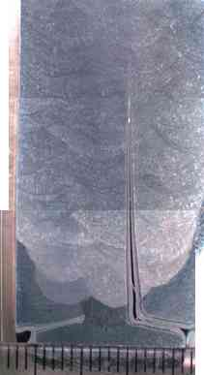
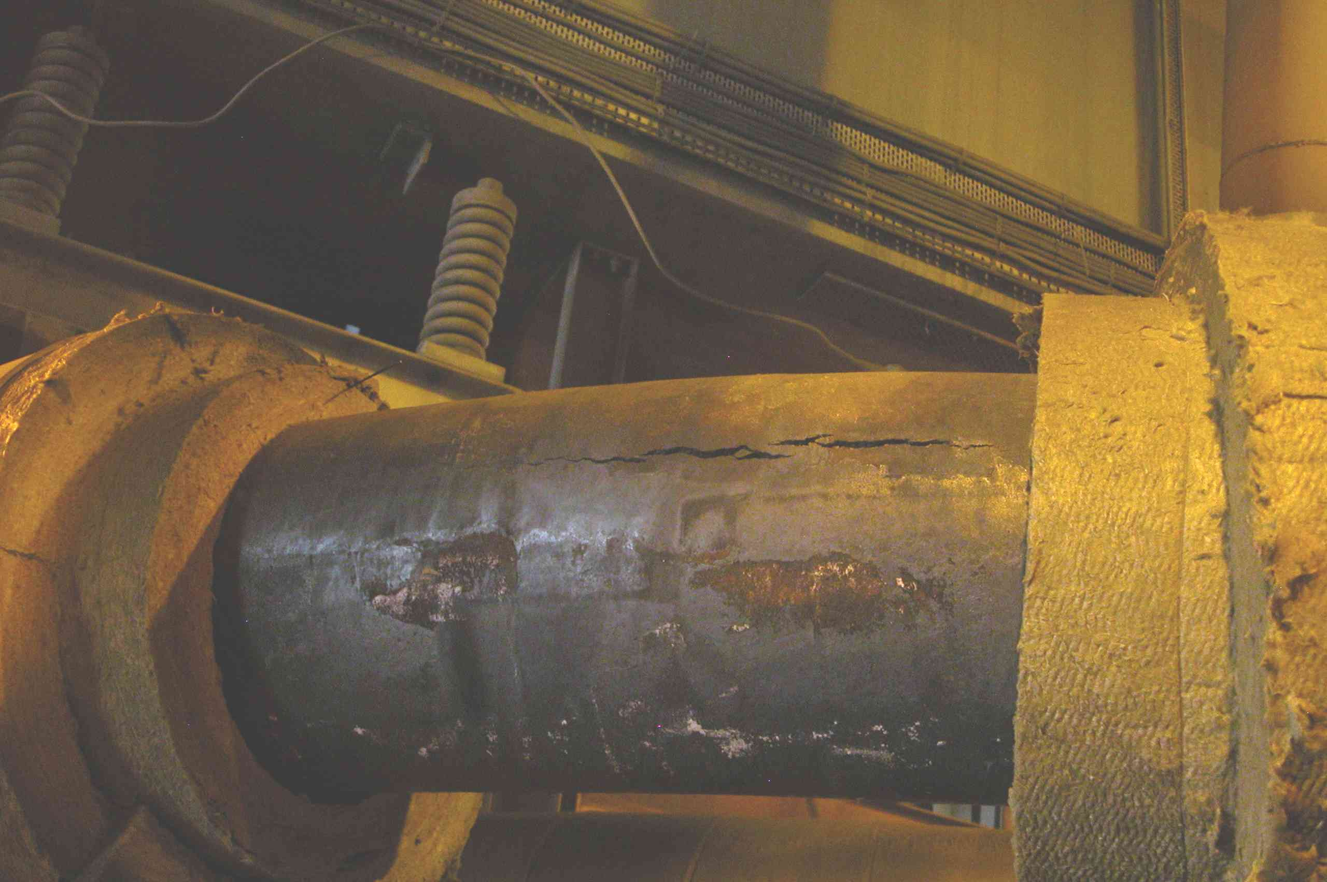

- Typical Bore Crack Figure 2: Creep Crack
Detailed information on the research undertaken to resolve these particular issues is provided by Fenton et al (2003) and Morris et al (2007a, b).
These examples illustrate some of the difficulties associated with correlating simulation models against test, where in these cases the test data is obtained directly from site measurements. These issues will be discussed further in the presentation along with recent experiences correlating measured crack growth against predictions from simulation models of large 500MW generator rotors. Further detailed information on these analyses has been provided by Morris et al (2007c).
- Low Carbon Future: R&D Perspective
E.ON is investing heavily in research development and deployment of many of the technologies associated with reducing emissions to mitigate the consequences of climate change. One such technology is the development of clean coal solutions, which utilise conventional fossil fuel stocks whilst minimising the effect of emissions and CO₂. Aspects of this technology are being assessed as part of the Ultra Supercritical COMTES700 project being collaboratively undertaken at Scholven Power Station in Gelsenkirchen, Germany. The engineering challenges associated with the development of this technology will be discussed during the presentation.
There are clearly many technical challenges to be overcome before the vision of a truly low carbon future can be realised.
References
Fenton, S.T., Morris, A., Mulvihill P, 2003. Investigation and analysis of CrMoV Bore Cracking, IOM 2nd International Conference on Integrity of High Temperature Welds, London

Morris, A., Dear., J, Kourmpetis, M., Puri, A., Maharaj, C., 2007a, Resolution of Creep Strain Measurements using the ARCMAC Strain Monitoring System”, ASME PVP2007, San Antonio, USA

Morris, A., Dear., J, Kourmpetis, M., Puri, A., Maharaj, C., 2007b, Researching Methods to Study Creep Strain Variations in Power Station Steam Plant”, ASME PVP2007, San Antonio, USA

Morris, A., Ing, T., Johnson, B., 2007c, Finger and Pole Tooth Cracking in Large Generator Rotors – A Case Study, NAFEMS World Congress, Vancouver Canada

